**Dot_matrix_display**

**1.Learning goals**

In this lesson we mainly learn how to use the music touch return and music button blocks of Yahboom piano expansion package.

By programming,we will make the micro:bit dot matrix displays different patterns by touching the seven white keys on the piano expansion board.

**2.Programming method**

**Mode 1 online programming:** First, we need to connect the micro:bit to the computer by USB cable. The computer will pop up a USB flash drive and click on the URL in the USB flash drive: **http://microbit.org/** to enter the programming interface. Add the Yahboom package **https://github.com/lzty634158/YB_Piano** to program.

**Mode 2 offline programming:** We need to open the offline programming software. After the installation is complete, enter the programming interface, click【New Project】, add Yahboom package:

**https://github.com/ Lzty634158/YB_Piano**, you can program.

**3.Looking for blocks**

The following is the location of the building blocks required for this programming.

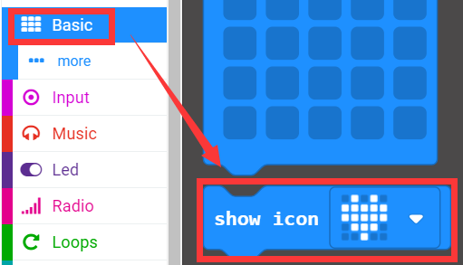

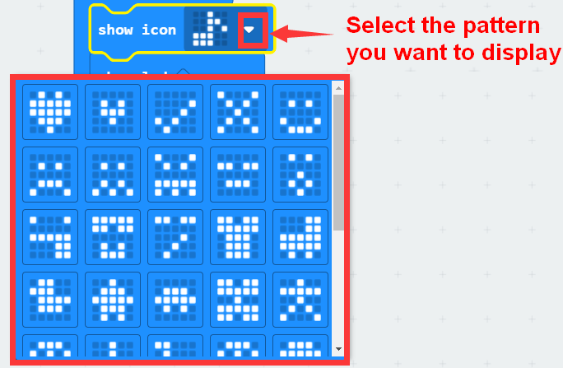

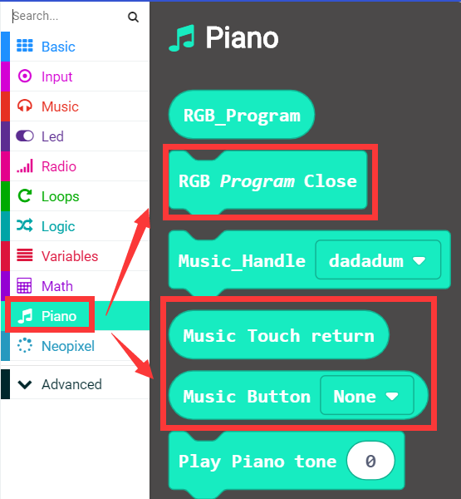

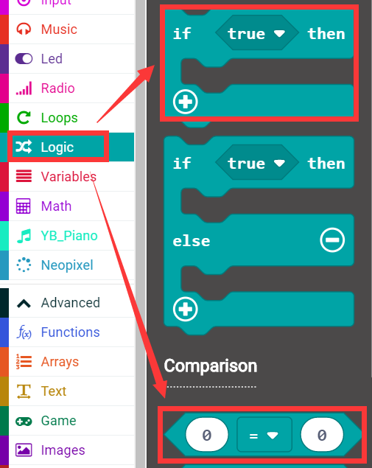

How to create a new variable：

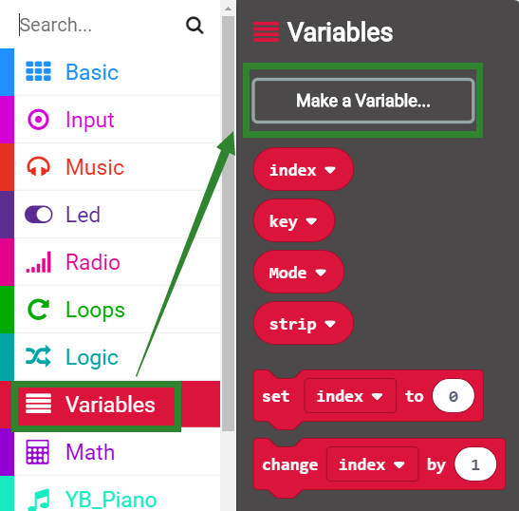

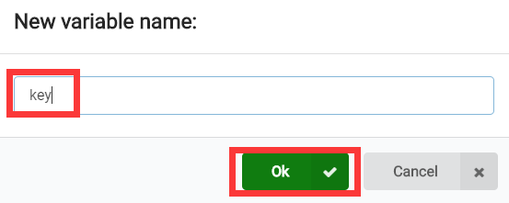

**4.Combine building block**

The summary program is shown below:

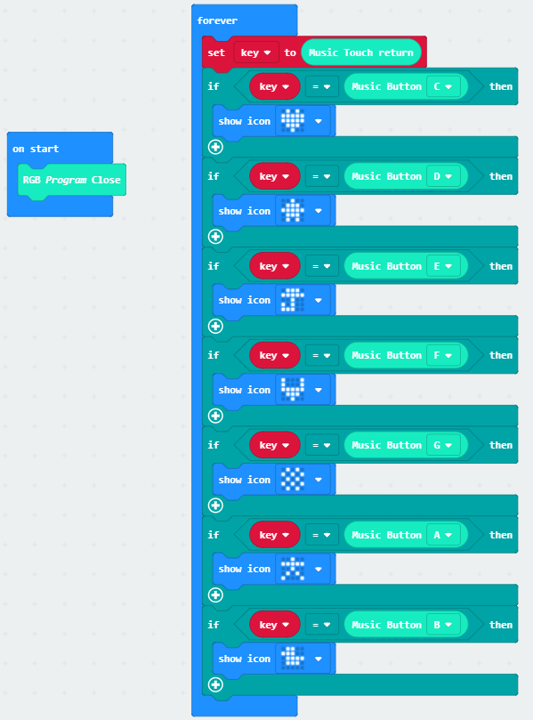

**5. Experimental phenomena**

After the program is successfully downloaded, when I touch the C, D, E, F, G, A, B keys on the piano expansion board, the micro:bit dot matrix will display different patterns, as shown below.

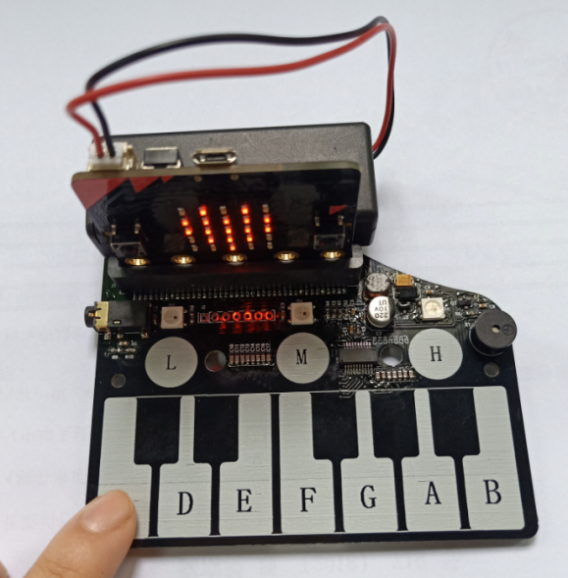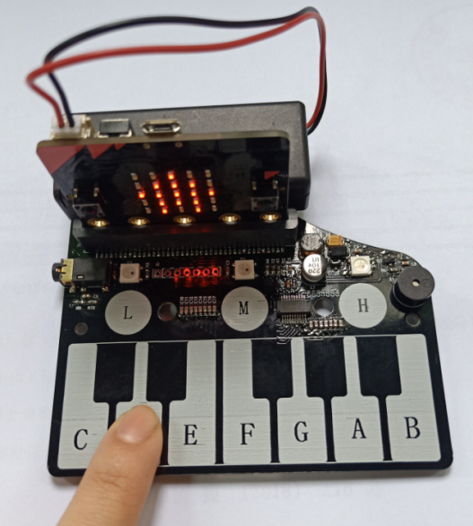

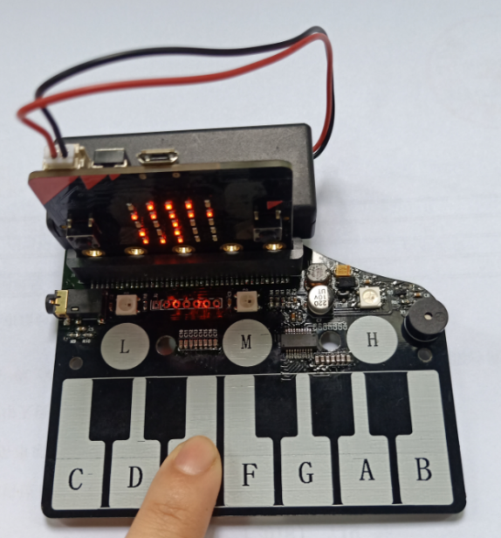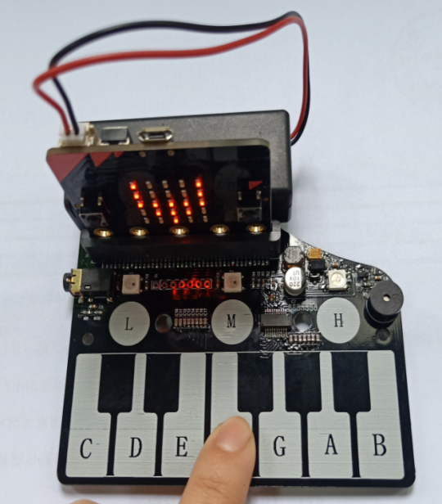

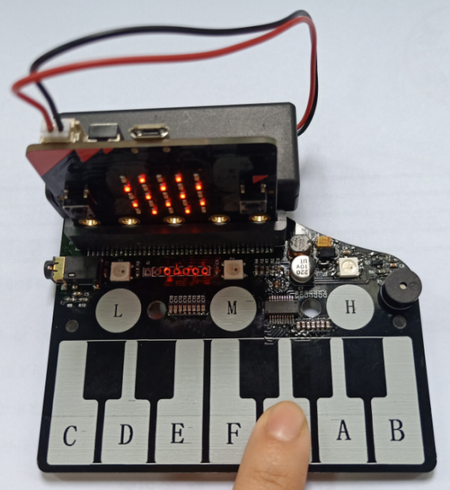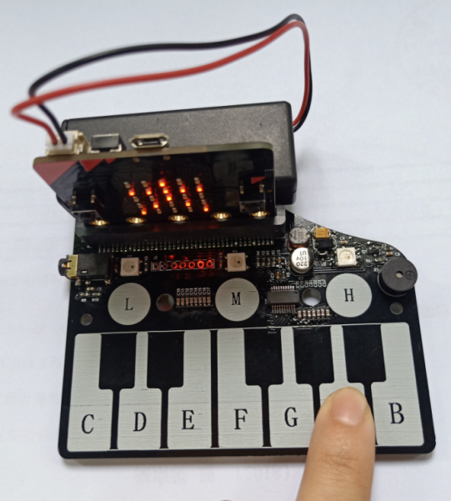

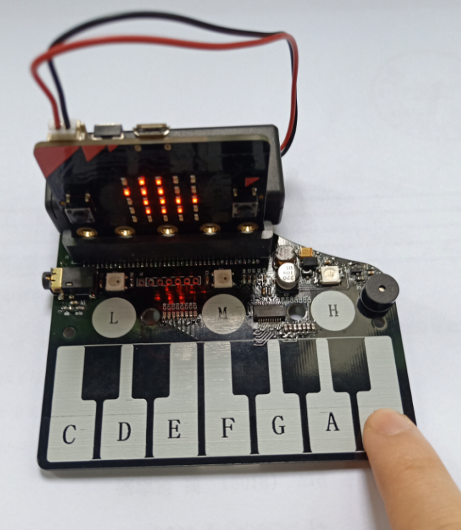

（If you want to display other patterns with other keys, you can modify the program yourself.）